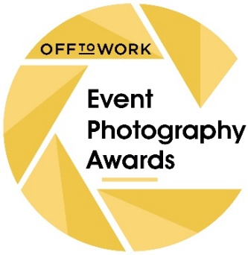
For Immediate Release
Event Photography Awards Relaunch with Double-Quick 2022 Competition
After a virtual awards ceremony in 2020 and a pandemic-enforced pause in 2021, the Off To Work Event Photography Awards have relaunched with a double-quick 2022 competition for images captured during 2020 and 2021.
Both professional and amateur photographers need to promptly review their portfolios though, as entries close on 31st July, with the awards ceremony set to take place at No.4 Hamilton Place in Mayfair on 4th October.
Two new categories have been added to the competition. ‘Covid Chronicles’ is a special one-off class which has already attracted evocative shots. The other is the classic photography genre ‘Portraits’.
A cash prize of £1,000 augments the professional cache of being the Overall Winner, while there are trophies for all category winners, as well as Runners-Up and Highly Commended acknowledgements.

Competition director, Graham Hill, commented: “Photography does so much to promote and sustain the events industry and as such we felt it was important not to wait until 2023 to relaunch the EPAs, especially as there have been some amazing images taken between lockdowns and at Covid-compliant events.

“With this in mind, we’ve organised a quick-fire double-year competition, hence the unusually short amount of time to submit event-related images. Encouragingly, past entrants are already uploading fabulous shots into a new system that also allows organisers and venues to enter photos on behalf of photographers that they have hired.”

Full list of Categories for EPA 2022
Behind The Scenes
Brand Activation & Experiential Events
Catering
Corporate Events & Conferences
Covid Chronicles – NEW
Cultural Events
Music Events
Portraits – NEW
Private Events
Sporting Events
Trade Shows & Exhibitions
Venues
Weddings

Best Amateur, Portfolio Award, Peoples’ Choice Award, Overall Winner

Attachments
EPA 2022 Logo (GIF)

EPA generic logo

EPA 2020 Overall Winner: ‘Eyes for Detail’ by Deb Porter

EPA 2019 Overall Winner: ‘Multitasking’ by Andrew Billington

EPA 2018 Overall Winner: “Rituals of the Water at Lost Village” by Andrew Whitton

A plethora of additional/alternative award-winning images are available upon request.

Additional Information
The Event Photography Awards were founded in 2014 by Philip Atkins, Managing Director of premier event staffing agency Off to Work, to celebrate the (often unsung) photographers who contribute so much to the validity, sustenance and marketability of the events industry.

EPA 2022 is the 8th edition of the competition.

Some 150 event photographs entered well over 1000 images into the 2020 competition.

The awards are open to both professional and amateur photographers.

Entries close for EPA 2022 on Sunday 31st July

The award events for EPA 2022 will held on Tuesday 4th October at No.4 Hamilton Place

It costs just £20 to enter a set of 5 photos, which is a lower price than similar competitions.

Off To Work Event Photography Awards remains a ‘not for profit’ exercise.

Key Suppliers & Supporters
- Organisers: Off To Work
- Venue: No.4 Hamilton Place
- Caterer: Blue Strawberry
- Production: Visions Group
- Marketing: Tembo
- PR: Triggerfish

For more information, photos and quotes, please contact:

Graham Hill
EPA Competition & Event Director
0771 204 5602
graham@eventphotographyawards.com

